Index

|  |  |
| --- | --- |
| 2 | Brief |
| 3 | First Stakeholder interview |
| 4 | Design Samples |
| 7 | Features to try (From design samples) |
| 8 | Low Fidelity Design 1 |
| 9 | Design 2 |
| 10 | Design 3 |
| 11 | Stakeholder Feedback: Low Fidelity Designs |
| 12 | High Fidelity Design 1 |
| 13 | Design 2 |
| 14 | Design 3 |
| 15 | Stakeholder Feedback: High Fidelity Designs |
| 16 | 3rd Stakeholder Interview |
| 17 | Colour Scheme |
| 18 | Stakeholder Feedback: Colour Scheme |
| 19 | Font Choices |
| 20 | Final Design (Attempt 1) |
| 21 | Stakeholder Feedback: Final Design (1) |
| 22 | Final Design (Attempt 2 - Last) |
| 23 | Stakeholder Feedback: Final Design (2) |
| 24 | Evaluation |

Brief

Standard: 91610

Stakeholder: Ben Alexander

*“I would like a website that links the user to different games. The games will be both Python and JavaScript. The JavaScript ones will just require a link but to run the Python games a tutorial will need to be implemented to show the user how to install Python and PyGame.”* – Ben

Brief and requirements (derived from Ben’s statement)

My goal is to design a website that can be used to navigate to different games over the internet and allow the user to download other games that cannot be played on the internet.

The website must…

* Show the games in different categories (e.g. Python on one page, JavaScript on another)
* Have a page showing the user how to install Python and PyGame.
* Have 3 or more pages
* Have hover-over text

First stakeholder interview

**Describe what you would like your website to look like.**

*It would be a basic page, with a white background and one main solid colour, maybe aqua, which would be used for anything with colour apart from the link images for the games and some text.*

**What colours are you thinking of for the text?**

*Black or white, depends on what colour it is on.*

**So whatever it is easier to see on?**

*Yeah, although for the tutorial I would like a completely new theme, preferably an over simplified version, just a back button (to the main website) and the tutorial.*

**What kind of layout are you thinking of?**

*I’m thinking of having the navigation bar at the top of the page with the page title above the links, I also want the navigation bar to stay on the screen, regardless of how far down the page the user has scrolled.*

*I’d like the game links to be centered in the page, in an even tile format, maybe 3 columns by however many rows we need.*

**What will the links look like?**

*Images, a thumbnail that may interest a user and then when hovered over, the name and what type of game, like is it Python or JS? I’ll get the images for you.*

**Who is the target audience?**

*Well, it’s kind of just to show off what can be done, not like a normal game website for kids. I want it to look professional but still a little fun.*

**Would you like any interactive elements?**

*Just when the user hovers over the game links.*

**Do you have a title in mind?**

*Not at the moment.*

Design Samples

|  |  |  |
| --- | --- | --- |
| Source/Image | Positives | Negatives |
| Image result for cool math gamesCoolmath-games.com | * Vibrant – A lot of colours to grab a user’s attention. * Shows a lot in a small space. * Contrast – Very easy to read bright text on dark background. * Has website link in very bright colours in the middle of the page, sticks it in the user’s head. * Font – A bold and bubbly font has been used, this will appeal more to the target audience of this website. * Lots of different shapes have been used, this goes with the math theme of the website. * All the games have a thumbnail, title and small description, allowing for the user to get better idea of what they might like. | * The colours take a lot of the attention away from the games on the page, making it a little harder to navigate the site. * The large number of items in the small space can give a crowded feel. |
| miniclip.com/games/en/ Image result for miniclip | * Simple – Sticks to 3 main colours, this leaves the user’s attention for the game links. * Based around the main content – The games are the main feature of the page. * Links and tabs are at the top of the page, the first thing the user sees (Apart from the logo). * Logo – The miniclip logo is in the top left, making it the first thing seen by the user. * All the games have an image and name for the link. * Popular games shown first. | * The plain text below the images for the game links looks lazy, as if no one cared to change it to the main font. * A lot of the text is very small, some people may find it hard to read. |
| kongregate.com Image result for kongregate | * Simple colour scheme – Uses red and greys to show different areas. * Tile format for games allows more games to be put in a small space without feeling crowded * All games have an image, title, description and rating, allowing the user to see what they might like before they even click the link. * The website logo is in the top left, making it the first thing seen by the user, sticking it in their head. * The links are just below the logo, this makes the user see them quickly and instantly know how to navigate the website. | * A lot of the text uses the default font, A user may find this boring and lazy. |
| youtube.com | * Colour scheme – The simple red and grey/white colour scheme is enough to distinguish different sections of the website easily but is still simple enough to give almost all of the user’s attention to the main items on the page (videos). * The website logo is in the top left, making it the first thing seen by the user. * The main navigation bar is on the left rather than the top. In this case it works well because the search bar is still at the top, having these separated avoids a bulky looking navigation bar. * The links in the navigation bar all have icons which may be easier to interpret quickly for some user’s. * All the video links are stuck quite close together allowing for many to be placed in a small amount of space, the gaps around this section keep it from feeling crowded. | * The website without the links is dull and uninteresting, this is normally okay as the links are usually bright and made to grab the user’s attention, but if they were basic and dull the site wouldn’t hold a user’s attention for very long. |
| soundcloud.com | * Navigation bar is a lot darker than the rest of the page, allowing it to stand out slightly, this helps the user as it contains links and a search bar. * A small logo is in the top left, making it the first thing seen * The main items take up most of the page. * All the main items (songs) have the album art, name and artist, plus a progress bar. Giving the user the most information without putting too much in a small space. * The main colour theme of orange and shades of grey keep the page simple while allowing different sections of the page to be split up without wasting too much space on borders. | * Because the main items take up so much space and are only put in one column, the page must be very long, making it take longer to get to each end. |
| Github.com | * Simple black and white colour scheme splits up sections of the page easily while saving space and keeping it simple. * The main items take up most of the page, giving them the most attention. * The main items are all in a grid format, this keeps it all sorted in a small amount of space. * The main items all have the name, a brief description and a label for what language(s) they’re written in. | * The page is very plain, with the only colour coming from blue text and an image of the user, this isn’t a big issue as the page is designed for programmers, who wish for a more professional look. * The main items do not have any image associated with them, leaving them looking quite plain. |

Features to try

|  |  |
| --- | --- |
| Features to add/try | Why |
| Tile theme | It keeps the items bunched up, just need to be careful that items do not become crowded (Have a decent amount of space between items).  Having the items bunched up helps keep the user’s attention in the one area, rather than having them look all over the place. |
| Logo in top leftImage result for miniclip | Doing this sticks the name/logo into the user’s head, this will help them remember the website and cause them the return at some point. |
| Simple colour theme | The simple colour theme is used to distinguish between different parts of the website without having to add spaces between them which can add up and create a space problem.  The colours to be used have not yet been decided but there will be extra care taken to ensure that they are not too over the top.  The idea is to avoid the same look as the coolmath games website. |
| Link image | Having a link image will allow a user to identify games they’ve tried before and give them a quick look at what it might be like if they have not.  The images will also provide the page with more colour which will help grab and hold the user’s attention. |
| Page based around main items | Ensuring the main items take up the majority of the page will help to fulfill the purpose of the website; showing and providing links to games. |
| Bold/large font for headerImage result for miniclip | Having a large font for the header/logo will help draw the user’s first glance to the logo, helping them remember the website. |

Low Fidelity Design 1

|  |  |
| --- | --- |
| Design 1 (Heavy influence) | |
| Page | About |
| JavaScript | This design is heavily influenced by the stakeholders’ requests.  This design has the title at the top, in the same section as the navigation bar. All the items are centered in a tile design and have more information when hovered over. The colours have not yet been chosen as in the high fidelity design they will be easy to change around and show the stakeholder what works best and see what they prefer. The navigation bars on all pages will use sticky positioning (Means they stay on screen regardless of scrolling)  Both the Python and JavaScript page have hover events; when the game links have the mouse hover over them, the image fades by about 50% and then the name of the game and what type it is will appear.  The Python page of the website has an additional section when compared to the JavaScript one. The section is just below the navigation bar (will not stay at the top of the screen unlike the navigation bar regardless of how far down the page the user is). This section will be the link to the Python install page.  The Python install page will contain the same colours as the other two pages but will have a completely different layout. This page will consist of one link with text at the top of the page (which takes the user back to the python page) and centered images which take up about 60% of the width of the page, the images will instruct the user on how to install Python and PyGame.  Stakeholder first thoughts  *Looks great, I’m just struggling to image what the colours will look like. I really like how you’ve added the link to the Python install page and then the link at the top to get back.* |
|  |
| Python |
|  |
| Python Install |
|  |

Low Fidelity Design 2

|  |  |
| --- | --- |
| Design 2 (Slight influence) | |
| Page | About |
| JavaScript | This design has a light influence from the stakeholders’ requests.  This design has the title at the top, in the same section as the navigation bar, but instead of having the links below the title, they are on the right side. All the items are centered in a tile design and show more information when hovered over. The colours have not yet been chosen as in the high fidelity design they will be easy to change around and show the stakeholder what works best and see what they prefer. The navigation bars on all pages will use sticky positioning (Means they stay on screen regardless of scrolling)  Both the Python and JavaScript page have hover events; when the game links have the mouse hover over them, the image fades by about 50% and then the name of the game and what type it is will appear. This is the same as design 1  The Python page of the website has an additional section when compared to the JavaScript one. The section at the top left of the page, just below the navigation bar (will not stay at the top of the screen unlike the navigation bar regardless of how far down the page the user is). This section will be the link to the Python install page.  The Python install page will contain the same colours and design as the other pages. Instead of having the main items in a tile format, this page the navigation bar at the top and below it, centered images which will take up about 60% of the width of the page, the images will instruct the user on how to install Python and PyGame.  Stakeholder first thoughts  *I really like having the link to the Python install page overlap the a little of the main items. Not a big fan of the links to the right of the page and I still reckon that the Python install page should have a different theme.* |
|  |
| Python |
|  |
| Python Install |
|  |

Low Fidelity Design 3

|  |  |
| --- | --- |
| Design 3 (No influence) | |
| Page | About |
| JavaScript | This design has little to no influence from the stakeholders’ ideas/requests. This is to show them other options and layouts.  The navigation bar in this design is above the title, unlike the other designs. Below the navigation bar, the title is centered in its own section covering the width of the page. The main items are all centered horizontally but are not placed side by side, this means that less items can be seen at once but more information about each can be given.  The main items/links do not have any hover events, unlike the other designs as the info is already shown.  The link to the Python install page in this design is placed on the right and has no overlap with the main items/links.  The Python install page is the same as the other two, with the only exception being the links are replaced with larger images  explaining how to install Python.  Stakeholder first thoughts  *This design doesn’t do it for me, I don’t like the navigation bar at the top, nor the title centered. I do like the look of the main items being wider though. If they are in the final design I would like them to have hover events though.* |
|  |
| Python |
|  |
| Python Install |
|  |

Stakeholder Feedback: Low Fidelity Designs

|  |  |  |
| --- | --- | --- |
| Design 1 (Heavy influence) | Design 2 (slight Influence) | Design 3 (No influence) |
| **What do you think?**  *I love it, it’s exactly what I imagined.*  **How about the features?**  *The navigation bar looks great, I think I’ll be keeping that the way it is, with the title at the top left and then links below it.*  *The tiles are nice, but I’m unsure on them now, I think they’re great, they’ll save a lot of space and still look really nice, but I don’t think I’ll need that much room.*  **What do you think of the Python install page?**  *The Python install page, it’s what I imagined, and it looks great, but it may look better if it kept with the theme of the website.*  *The link to the Python install page as well, good, but could it be better? It’s for sure better than design 3.* | **What do you think?**  *Out the current designs, I think it looks the best.*  **How about the features?**  *Like what I said about design 1, I am unsure about the tile design when compared to the other layout in design 3.*  **What do you think of the link to the Python install page?**  *The link to the Python install page I think is the best part, it doesn’t take up much room, doesn’t take any away from anything else but can’t be ignored and still looks nice.*  *I do like having the website theme on the Python install page as well, it looks better than I expected.*  **How about the change with the navigation bar?**  *The links on the right of the navigation bar is kind of cool, I still think they look best on the left, just under the title though.* | **What do you think?**  *Honestly, nasty.*  **Do you like anything about it?**  *The only thing this design does well is the game links, I actually like them with just one per row, I still want the hover events though.*  *Everything else is a big no.*  *The title should be at the top, to the left, the navigation bar should be below it. It looks quite messy this way.*  *The link to the Python install page takes up far too much space and looks bulky.*  *The images on the Python install page need to be wider and have gaps between them.* |

High Fidelity Design 1

|  |  |
| --- | --- |
|  | This design is a refined, digital make up of the 1st low fidelity design.  No changes have been made to this because the changes the stakeholder suggested would cause it to be identical to another design.  Another reason this is kept the same as the low fidelity is because it is what the stakeholder suggested and it will be good to show them what they suggested and compare it to their chosen design.  This design uses the centered tile design to show many items in a small space, the gaps between these items stop it from seeming cramped.  The navigation bar and title share the same solid background but the text colours are different. The title and links in this area are white and black (These can be switched if the chosen background is light).  The link to the Python install page link is a banner below the title section with text of varying size. The text and background are both light, this is so the attention is not taken away from the main items, having it quite large and below the navigation bar ensures it is seen and read.  The Python install page consists of images (some containing links). These show the user how to install the Python software.  **The colour scheme of black, white and various shades of purple are not the final colours, they are just to show the stakeholder what the layout could look like. The font (Unispace) is also not final.** |
|  |
|  |

High Fidelity Design 2

|  |  |
| --- | --- |
|  | This design is a refined, digital make up of the 3rd low fidelity design.  No changes have been made to this because the changes the stakeholder suggested would cause it to be identical to another design.  Another reason this is kept the same as the low fidelity is because it is the design that sways the most from what the stakeholder first wanted. This means it is introducing new ideas.  This design still has the links in the center but they are not put side by side, they instead take up more space with one taking up the width of the center section.  The navigation bar is above the title in this design, with a darker background than it, this helps to differentiate from the two sections.  The link to the Python install page is a solid section to the left of the main items and has the text rotated. It is similar to the link in design 1 but it is rotated and to the left.  The Python install page continues the theme of the last two pages but just replaces the main items (game links) with large images that instruct the user on how to install the Python and PyGame software.  **The colour scheme of black, white and various shades of purple are not the final colours, they are just to show the stakeholder what the layout could look like. The font (Unispace) is also not final.** |
|  |  |

High Fidelity Design 3

|  |  |
| --- | --- |
|  | This design is a digital make up of a mix of the 3 designs, using all of the features that the stakeholder was interested in.  This design still has the links in the center but they are not put side by side, they instead take up more space with one taking up the width of the center section.  The navigation bar is below the title in this design, with a lighter background than it, this helps to differentiate from the two sections.  The link to the Python install page is a small triangular section just below the navigation bar, the text in the link is rotated 45 degrees anti-clockwise.  The Python install page continues the theme of the last two pages but just replaces the main items (game links) with large images that instruct the user on how to install the Python and PyGame software.  **The colour scheme of black, white and various shades of purple are not the final colours, they are just to show the stakeholder what the layout could look like. The font (Unispace) is also not final.** |
|  |  |

Stakeholder Feedback: High Fidelity Designs

|  |  |  |
| --- | --- | --- |
| Design 1 (Heavy influence) | Design 2 (No Influence) | Design 3 (Mix) |
| **What do you think?**  *It’s nice and simple like I requested*  *Now that I can see it put together, it’s very, very simple, almost a little boring. It need more colour, or at least shades of purple or whatever colour it will be.*  *The hover events looks nice though.*  *Something that I find a bit odd is the link to the Python install page, it takes up a lot of space and that’s what I wanted to avoid but it looks really good. I’m torn on how I would like the link.*  *For the Python install page itself, it does need more to it, I am still hesitant on having the whole layout; title and all.* | **What do you think?**  *Not as bad as I thought it would be.*  **What do you think of the header section?**  *Well, I like how the navigation bar and title have their own backgrounds but it needs to be completely rearranged.*  **How so?**  *Title in the top left, navigation bar below it. Oh, and keep the darker colour at the top.*  **How about the new design for the links?**  *Yeah, I like them*  **Compared to the tiles?** *I think this design is a little better, it looks just as good but also has more information up front.*  **What about the Python install page?**  *Firstly, the link to it isn’t really what I want, it’s far too bulky.*  *The page itself isn’t too bad, I still think it needs to be simplified more, maybe take out the title section?* | *Brilliant! The JavaScript page that is.*  **Okay, so what about the other two?**  *Like I’ve said about the last 2 designs, I would like the Python install page to have a simplified theme. What you’ve presented here is nice, but I’m sticking to what I said*  *Now that I’ve seen the different styles for links to the Python install page in digital format, I am a little torn, the banner version looks better than I thought it would. I’m going to stick to the style in this design.* |

3rd Stakeholder interview

**Firstly, the colours and fonts you saw were only to show what the website could look like, we’ll go through the choices once a layout has been chosen.**

**So, are you happy with any of the designs presented?**

*Yes, I do like and would be satisfied with the 3rd digital design [design 3: mix]. The other two, not so much.*

**What do you not like about that design?**

*Well, it’s not that I don’t like it, but the only thing I can think of is how it is very simple, it might be cool using a light swirly pattern in some of the colours, kind of like the top left of Ms Word*. *[Example to the right]*

*Oh, also the Python install page should be more basic, preferably take out the title section.*

**What do you like about that design?**

*Well, I like the header in the top left with a dark background and the navigation bar just below it with a lighter background.*

*The wider games links are nice because they can give off a lot of information and prevent the links from seeming crammed in to a small area.*

*The [Python install page] link hanging over the corner of the Python page looks nice and doesn’t take up much space.*

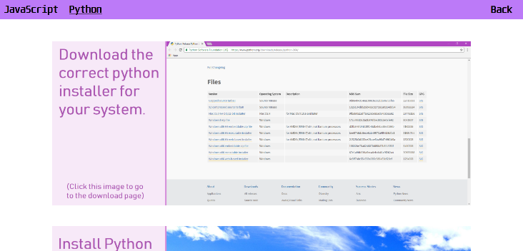

**Is this what you were thinking for the Python install page?**

Yes! That’s what I want.

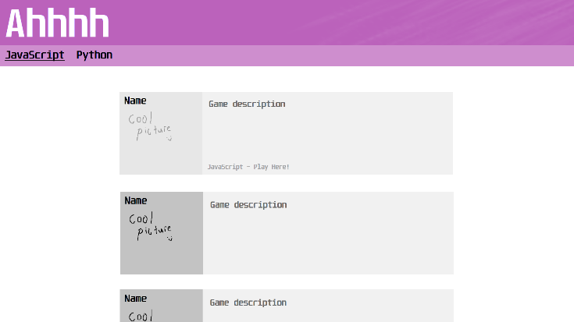

**And how about this for the pattern in the header?**

*Again! That’s it!*

Colour Scheme

Message from stakeholder: “*One thing the website must have is a white or dark grey background, I don’t want any other colour. I would also like there to only be one colour of different shades as this website should simple yet professional.”*

Due to the stakeholders specifications, this website is restricted to a monochromatic colour palette.

|  |  |  |
| --- | --- | --- |
| Colours | In context (Light) | In context (Dark) |
|  |  |  |
|  |  |  |
|  |  |  |
|  |  |  |

Stakeholder Feedback: Colour Scheme

**So, what are your thoughts?**

*Wow, the darker theme looks amazing. I’ll certainly be going for a darker background.*

**What about the main colours?**

*I’m not too fond of the green or orange. The purple, that’s my favorite.*

**What do you like about the purple?**

*It’s different, I only know of one other nice website with a purple theme (GitHub), but the site does it well.*

**What don’t you like about the other colours?***Well, the blue gives it a kind of sad feel, a feeling you’d associate with blue. Green? Um, that reminds me, and I assume others of nature and that stuff, this is not that. Orange is a bit aggressive, you know? Obviously I’m looking for reasons here, It’s primarily that I like the look of the purple more.*

Font Choices

Because this website must have a professional, and ‘clean cut’ theme, a serif font will not suit, and thus only sans serif fonts will be tested. The websites analyzed earlier also all used a sans serif font.

|  |  |  |
| --- | --- | --- |
| Font | Test | Stakeholder feedback |
| Arial |  | *It’s kind of basic, but I guess that’s not a bad thing. It doesn’t have that kind of goofy feeling that I’m after, it’s too ordinary.* |
| Courier |  | *This would go well with the theme of the games. I do like the idea of the pixelated font, but it just doesn’t go with the rest of the website, like, it should be a little bit playful with curves, like Arial, but not.* |
| Unispace |  | *Yes! I love it.*  *It is smooth, bold, simple, and is that little bit different from the other fonts.*  **How is it different?**  *Unispace has more straights, it’s curves are only for corners, where Arial uses them all over the show, this makes it look kind of futuristic. It’s basic and to the point but is still curved and smooth* |

Final design (Attempt 1)

|  |
| --- |
|  |
|  |
|  |

Stakeholder Feedback: Final Design (1)

**What are your first thoughts on this design?**

*Brilliant, It has everything I want and it love the way it looks.*

*It’s simple yet not dull or boring, it contains everything I want without having it crammed into one spot, everything is spaced nicely to ensure it’s not cramped but it’s not too spaced that it seems empty. Yeah, it’s great.*

**What do you not like about this design?**

*Nothing..?*

**Are you satisfied with this design?**

*For sure.*

**Are there any changes you’d like from this?**

*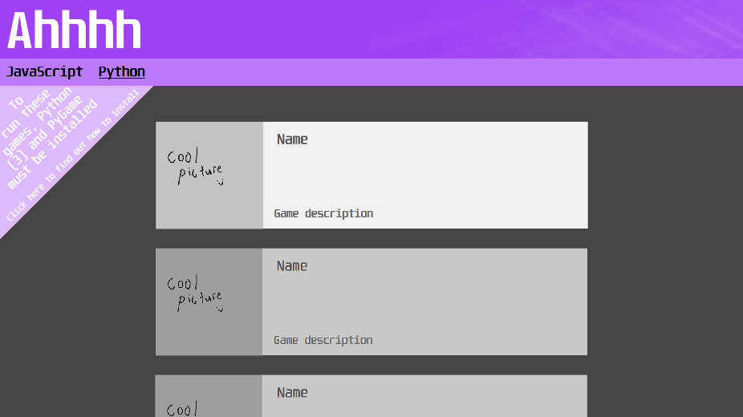Kind of, they are more interactive features. I would like for the whole game link to be darkened or a little transparent, then when it is hovered over, it becomes brighter. I’d like it to be a more subtle thing but still noticeable. The same type of thing with all links would be good, but it must be subtle.*

*Maybe also have the game name next to the thumbnail? Could we see what that look like?* [Image on right]. *Yes! I like that a lot.*

**Is there anything else that you dislike about this?**

*Nope, it’s great.*

Final design (Attempt 2)

|  |
| --- |
| C:\Users\Johnny\AppData\Local\Microsoft\Windows\INetCache\Content.Word\JavaScript.png |
| C:\Users\Johnny\AppData\Local\Microsoft\Windows\INetCache\Content.Word\Python.png |
| C:\Users\Johnny\AppData\Local\Microsoft\Windows\INetCache\Content.Word\Python Install.png |

Stakeholder Feedback: Final Design (2)

|  |
| --- |
|  |

**What do you think?**

*I like it.*

**Anything you don’t like?**

*Nope, I love it.*

**Are you happy with this?**

*Yeah, It does what I need it to, will be easy to use and looks great.*

Evaluation

The website must…

* Show the games in different categories (e.g. Python on one page, JavaScript on another)
* Have a page showing the user how to install Python and PyGame.
* Have 3 or more pages
* Have hover-over text

The website satisfies the brief through the use of different pages for the different types of games.

It has a separate page to show the user how to install Python and PyGame.

It has 3 pages; JavaScript games, Python Games, Python install Tutorial

When the links are hovered over, they display more information.

The website plan satisfies the stakeholder with no negative feedback or uncertainty as I have worked through many different ideas and layouts to ensure the best design has been chosen.

I am satisfied with this design because not only does it exceed the expectations set by the brief and stakeholder, but I believe the design is smooth, professional and elegant, the navigation is simple and straight forward and will function as any other professional website should.